Ideation Stage
Brainstorm & Idea Prioritization Format

Date | 18 June 2026
Team ID | -
Project Name | HouseHunt
Maximum Score | 4 Marks

Developer Details and Selection the Problem Statement
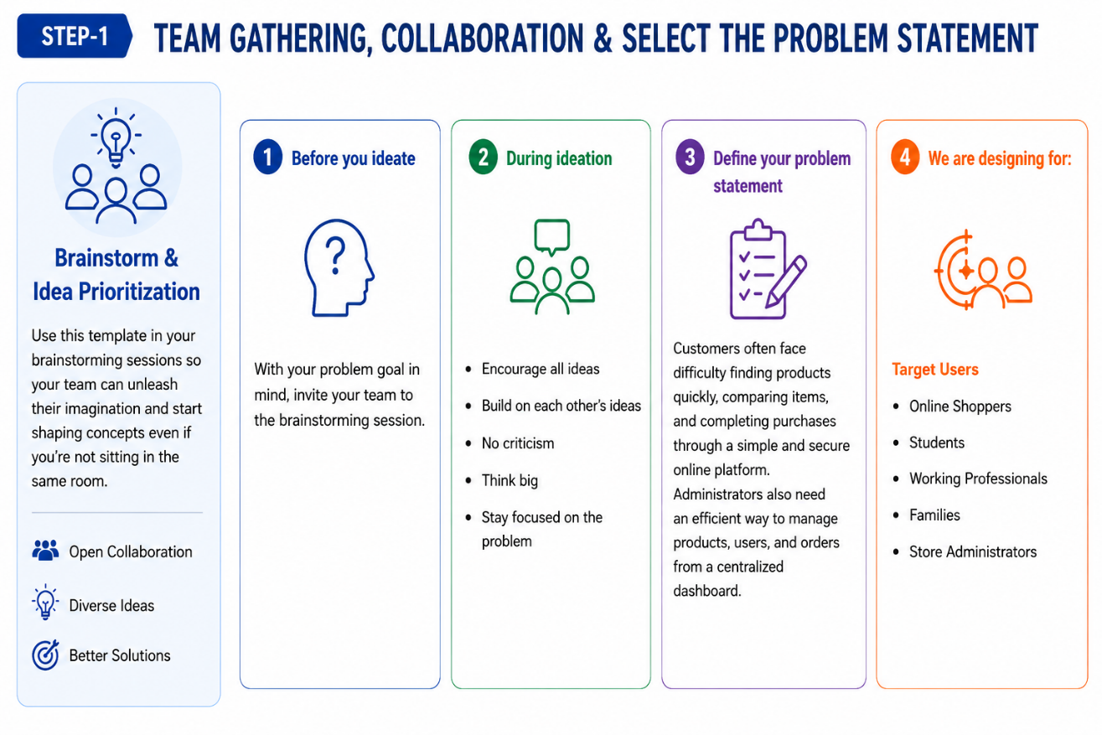

Brainstorm, Idea Listing and Grouping

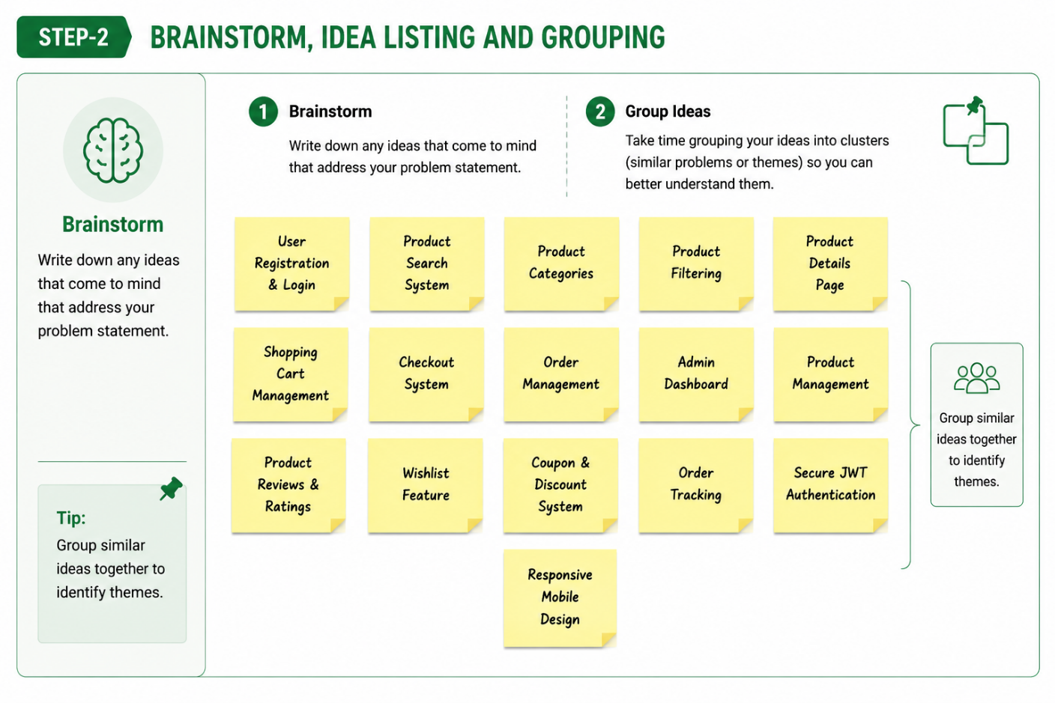
Idea Prioritization
